
Figure 3: Input Images

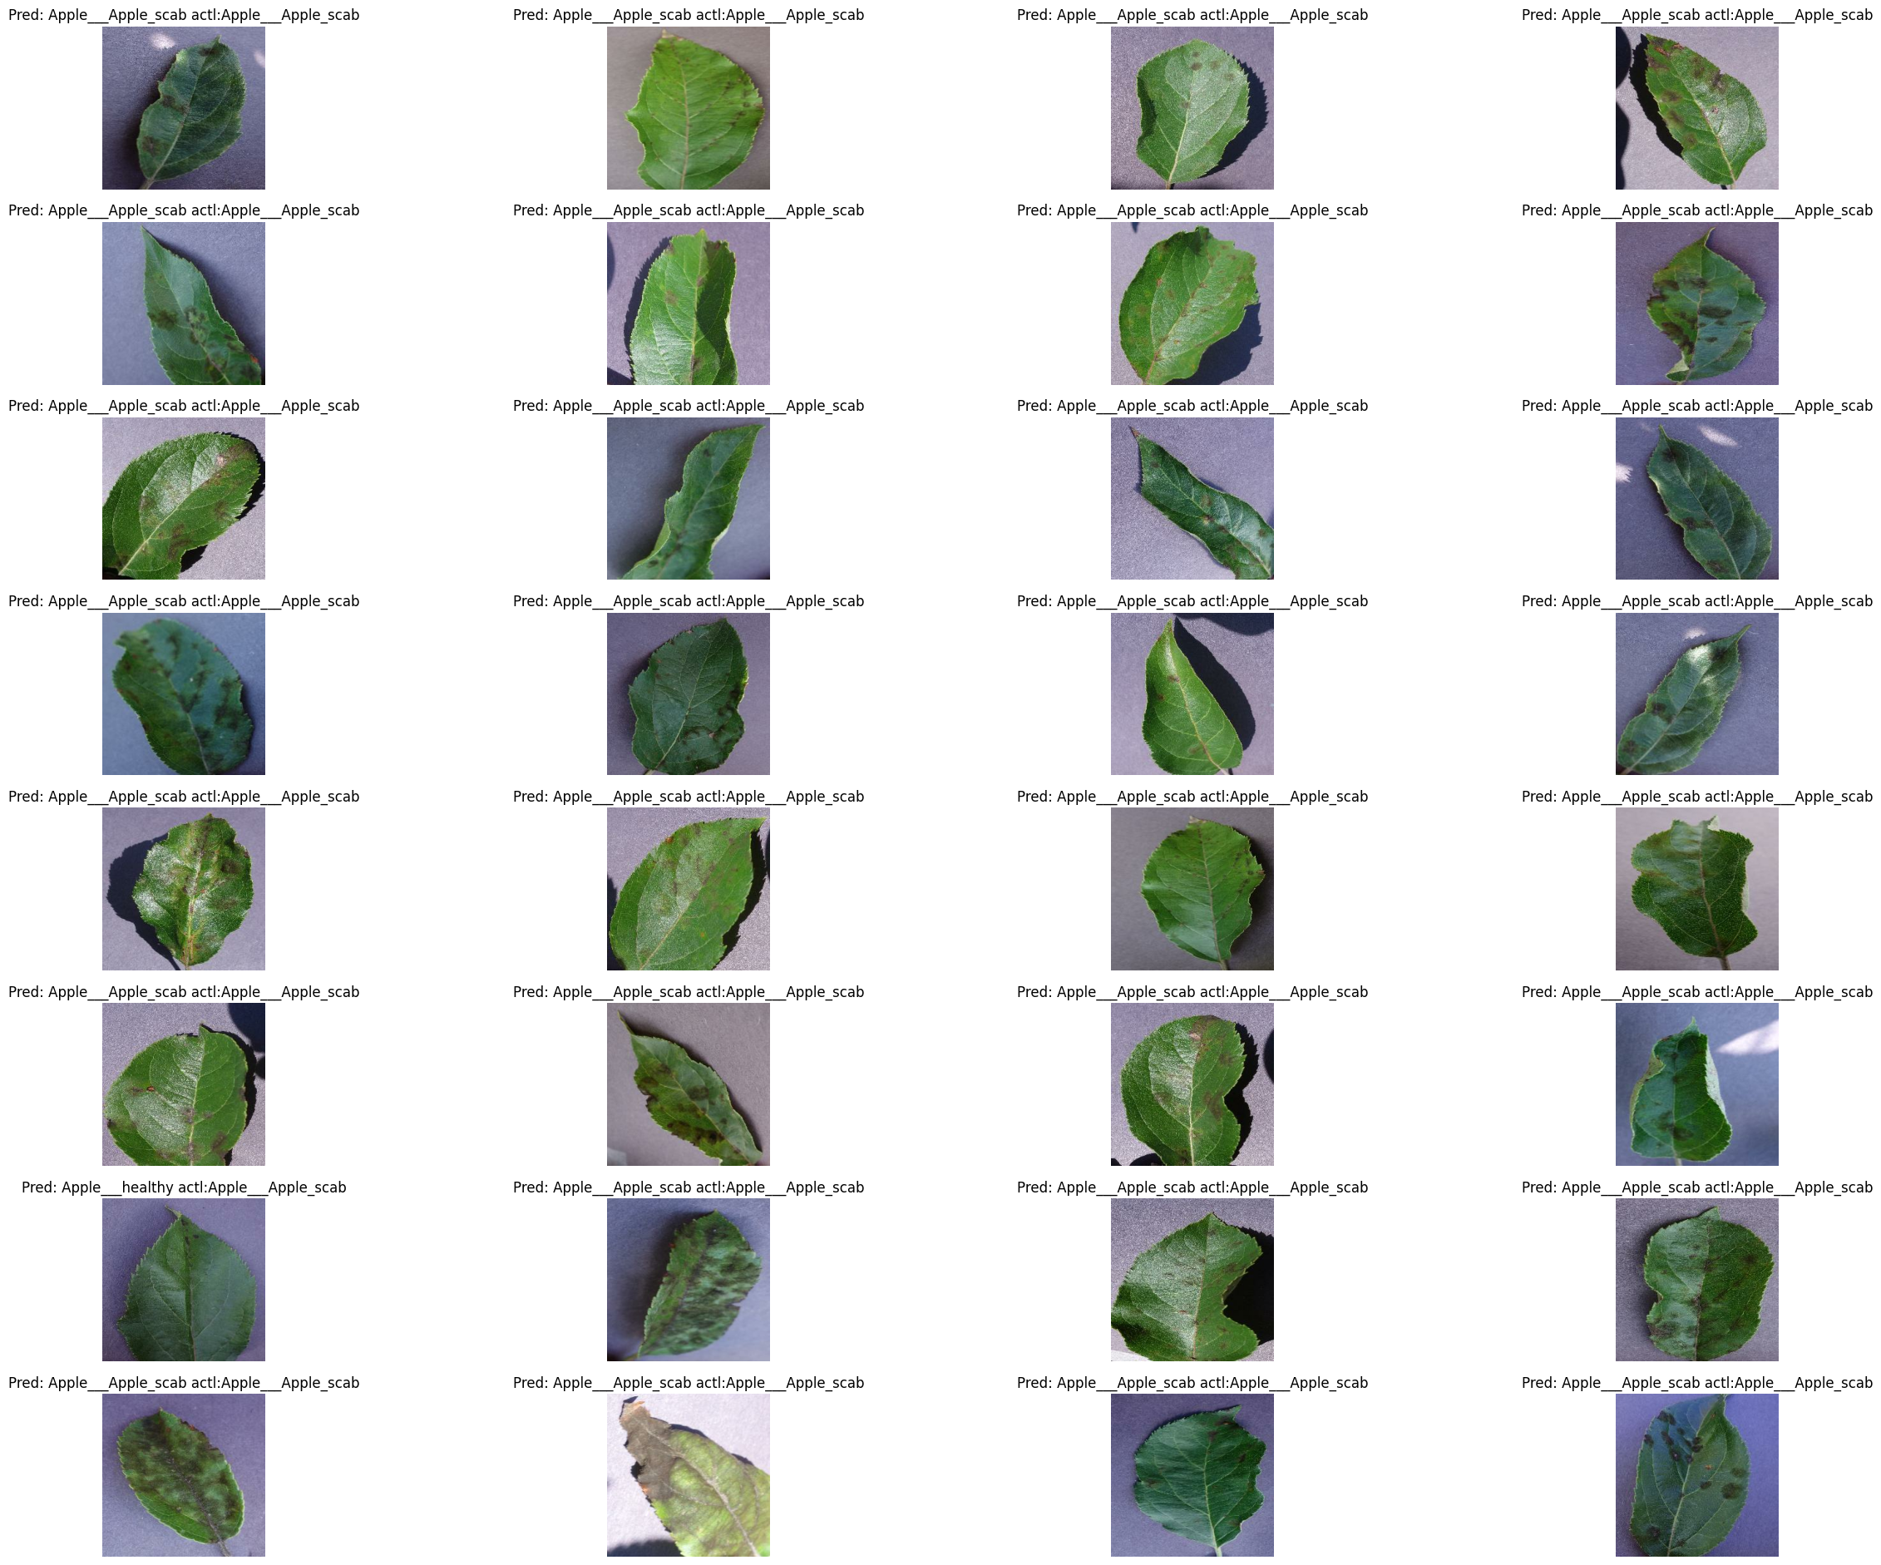
Image 1: Apple Leave Image 2: Apple Leave
Figure 4: Output Images
- The provided information mentions that the model was able to correctly classify two different images of apple leaves with disease, apple scab.
- It is important to note that the model's ability to correctly classify these two different images of apple leaves with disease demonstrates its effectiveness and robustness in real-world scenarios.
- Resnet50 using transfer learning when we fine-tuned on some specific parameters for the plant disease detection task we achieved training accuracy of 99.61%. & testing accuracy of 98.72

Result and Conclusion
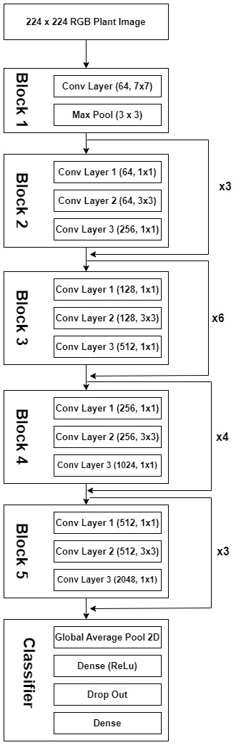
Figure 2: Generic architecture of Resnet50
- ResNet50v2 has 50 layers and uses residual connections to enable the efficient flow of gradients through the network, allowing it to overcome the vanishing gradient problem.
- It uses batch normalization and advanced activation functions, such as the Rectified Linear Unit (ReLU), to speed up the convergence of the network during training.
- ResNet50v2 uses a modified bottleneck structure that reduces the number of parameters in the model, making it more computationally efficient.
- It has achieved state-of-the-art performance on several image recognition benchmarks, including the ImageNet Large Scale Visual Recognition Challenge.

- Khakimov, A., Salakhutdinov, I., Omolikov, A., & Utaganov, S. (2022). Traditional and current-prospective methods of agricultural plant diseases detection: A review. In IOP Conference series: earth and environmental science
- Talreja, R., Jawrani, V., Watwani, B., Sengupta, S., Rohera, P., & Raghuwanshi, K. S. (2022, May). AgriCare: An Android Application for Detection of Paddy Diseases. In 2022 3rd International Conference for Emerging Technology (INCET)
- Pantazi, X. E., Moshou, D., & Tamouridou, A. A. (2019). Automated leaf disease detection in different crop species through image features analysis and One Class Classifiers. Computers and electronics in agriculture, 156, 96-104.
Reference
Prof. Dr. Rajkumar S
AgriEasy: Harvesting the Future of Agriculture

Bisuraj Sharma*, Ujjwal Tiwari**, Bijan Shrestha**, Anish Shrestha**, Sumit Kumar Mandal**
#Scope – Vellore Institute of Technology

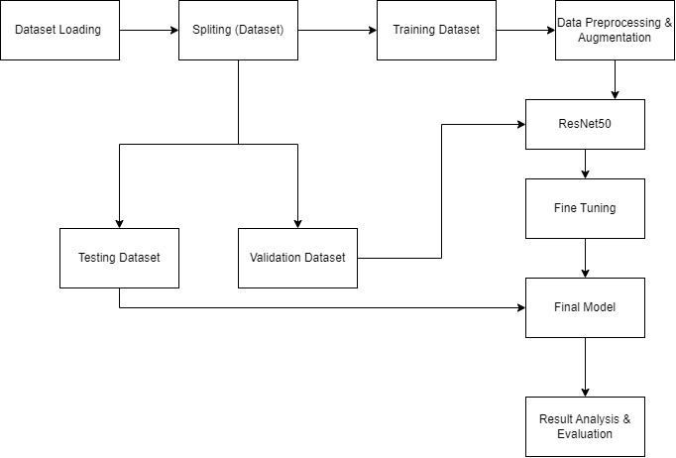
Figure 1: Block Diagram
- Load the dataset of images of diseased and healthy plants obtained through various API calls.
- Split the dataset into training, validation, and testing sets to train, tune, and evaluate the model's performance.
- Preprocess and augment the images to ensure they are in a format that can be fed into the model and to increase the dataset size.
- Fine-tune the ResNet 50 convolutional neural network architecture to classify the plant diseases accurately.
- Evaluate the final model's performance on the testing dataset using metrics such as accuracy, precision, recall, and compare it with other state-of-the-art models to determine its effectiveness.
- ResNet50v2 is a convolutional neural network architecture designed for image recognition tasks.
- It is an improved version of the original ResNet50, which includes additional shortcut connections to facilitate deeper training and improve the model's accuracy.
Methodology
- To develop a machine learning model for accurate detection of plant diseases from images. This will require a large dataset of images of diseased and healthy plants obtained through various API calls. The model will use computer vision techniques to analyze images and extract disease presence features.
- The model will undergo regular retraining and validation using new data obtained through API calls from different sources to improve its accuracy. The objective is to provide farmers with a powerful model that can detect plant diseases, ultimately reducing crop damage and increasing crop yields. The model can be integrated into existing agricultural technology platforms or deployed as a standalone tool for farmers to use. This will lead to a more sustainable and profitable agricultural industry.
Scope of the Project
- Farming is essential for our survival, with over 90% of the global population involved in it. However, climate change, pollinator decline, and plant diseases threaten our food security. These diseases can have disastrous consequences for farmers, who struggle to prevent crop damage and some diseases are hard to spot.
- A recent report estimates that invasive pests cost countries at least $70 billion annually and that as much as 40% of the world's agricultural crops are lost to pests each year. Improved monitoring and surveillance systems as well as more eco-friendly and comprehensive pest management techniques are necessary.
Motivation
- Plant diseases may have a big impact on agriculture, reducing overall on production or even causing total crop failure, which is expensive for farmers. Early disease detection helps to adopt effective control measures, such as the use of pesticides or other control measures, which can help to lessen the disease's detrimental effects on crop production. Early disease detection also helps to reduce crop losses and prevent the disease from spreading to nearby plants.
- The Machine Learning based image processing approach is used for the identification of diseases in plants based on symptoms that arise on leaves. The disease identified by the project includes bacterial leaf blast, neck blast, leaf scald, false smut and many more. This system is expected to be more accurate as compared to the existing ones so that it can help farmers to identify diseases in different plants precisely and treat them effectively.
Introduction

